Data Collection Download the Dataset

|  |  |
| --- | --- |
| Team ID | PNT2022TMID30722 |
| Project Name | AI-Powered Nutrition Analyzer for FitnessEnthusiasts |

Download The Dataset

* Collect images of different food items organized into subdirectories based on their respective names as shown in the project structure.
* Create folders of types of food items that need to be recognized.
* In this project, we have collected images of 5 types of food items 'apples', 'banana', 'orange', 'pineapple' and 'watermelon', they are saved in the respective subdirectories with their respective names.
* For more accurate results we can collect images of high resolution andfeed the model with more images.
* For more accurate results we can collect images of high resolution andfeed the model with more images.
* You can download the dataset used in this project using the link below.

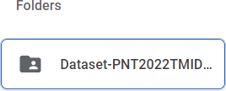

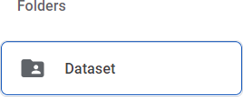

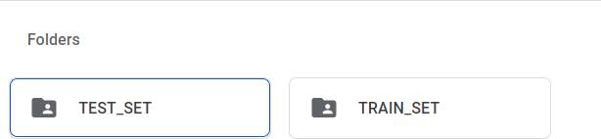

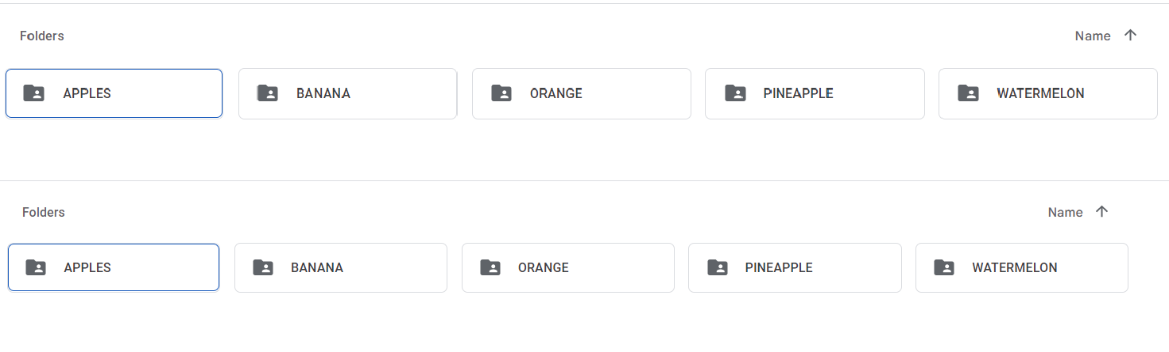

Drivelink:

[https://drive.google.com/drive/folders/1INNsCy3Sn4jQrlp6kc6_gsbKWY1A4Wu7?usp=share_link](https://drive.google.com/drive/folders/1INNsCy3Sn4jQrlp6kc6_gsbKWY1A4Wu7?usp=share_link%0c)